

**Disease Classification in Potato Plants**

## **Instructor**

Miss Sumaiyah Zahid

## **PROJECT TEAM**

Huzaifa Jawad 20k-0175

Moaaz bin Sajjad 20k-0154

Murtaza Salman 20k-0398

FAST SCHOOL OF COMPUTING

NATIONAL UNIVERSITY OF COMPUTER AND EMERGING SCIENCES KARACHI CAMPUS

December 2023

**Objective**

The primary objective of this project is to leverage deep learning techniques to classify images of potato plants into three categories: Early Blight, Late Blight, and Healthy. The goal is to determine which model architecture is most effective at identifying and differentiating between these plant conditions.

**Problem Statement**

Accurate and early detection of plant diseases can significantly reduce losses in agricultural productivity. Traditional methods of disease detection in plants require expert knowledge and are often time-consuming and labor-intensive. This project explores the use of convolutional neural networks (CNNs) to automate the process of detecting diseases in potato plants using image data, aiming to increase the speed and accuracy of diagnosis.

**Methodology**

1. **Data Collection and Preparation:**

* The dataset, sourced from the "Plant_Village" directory, includes images categorized into three classes (Early Blight, Late Blight, Healthy).
* Images are resized to 256x256 pixels and batched with a size of 32 for processing.

1. **Model Exploration:**

* **Custom Model**: A basic CNN model tailored specifically for this dataset.
* **LeNet-5**: An early and simple CNN architecture, used as a baseline for performance.
* **AlexNe**t: A deeper and more complex model known for its success in large scale image recognition.
* **ResNet**: Incorporates residual connections to enable training of very deep networks.
* **GoogLeNet (Inception)**: Utilizes a complex inception module to capture information at various scales.

1. **Training**:

* Each model is trained using the same dataset to ensure consistency in comparison.
* Training is performed for 30 epochs, with parameters adjusted according to the requirements of each architecture.

1. **Evaluation**:

* The models are evaluated based on accuracy and loss metrics.
* Comparisons are drawn to identify the most effective architecture in handling the specific challenges posed by the dataset.

**Results**

1. **Custom Model**



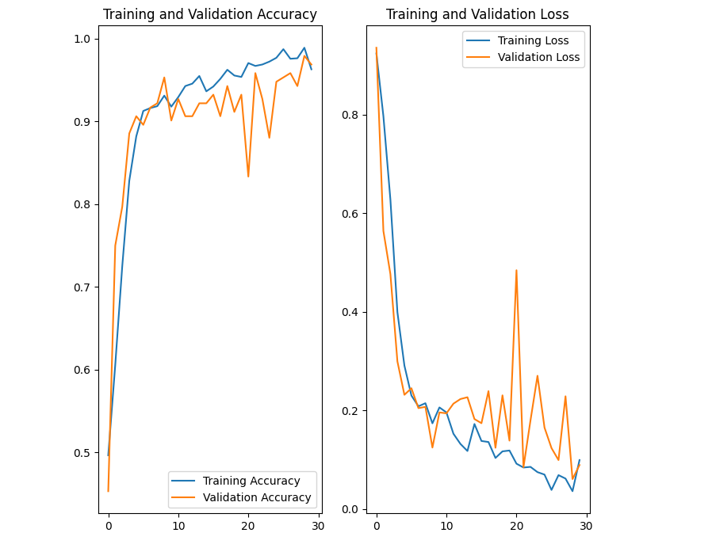

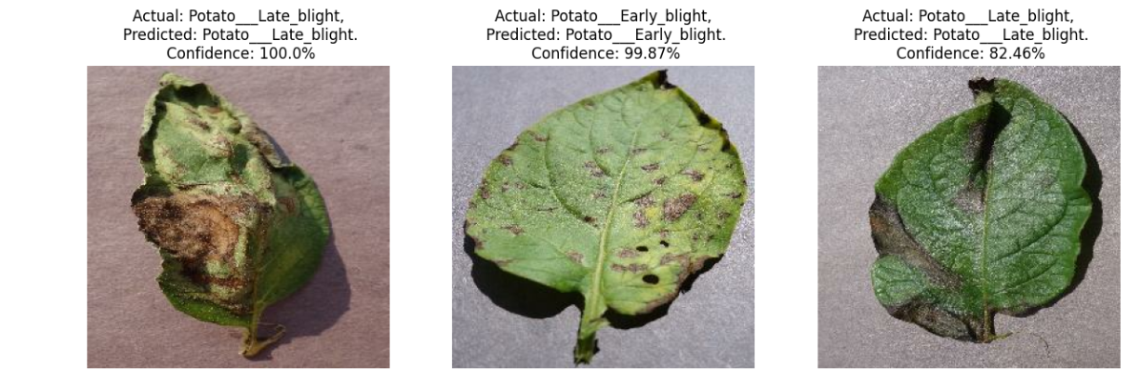

1. **LeNet-5**

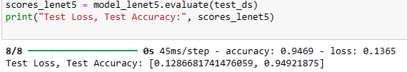

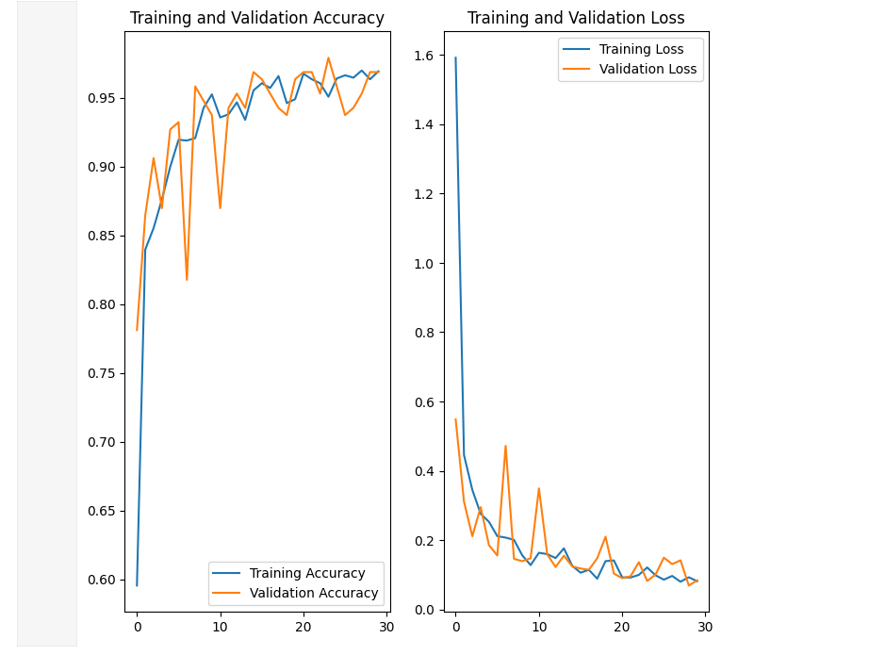

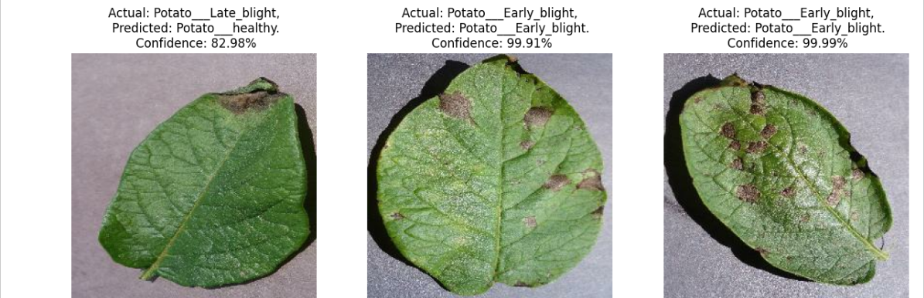

1. **AlexNet**

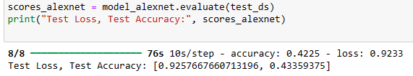

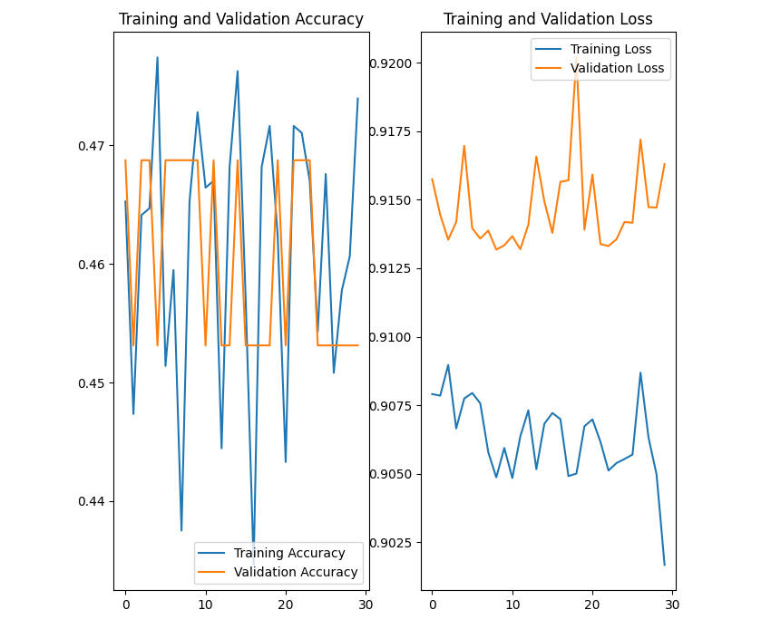

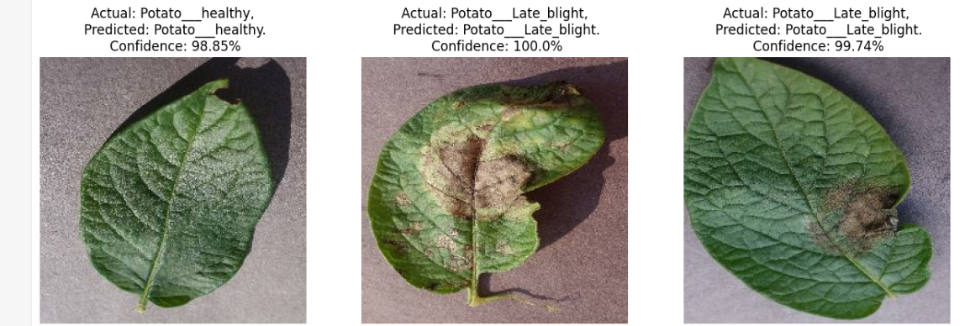

1. **GoogLeNet**

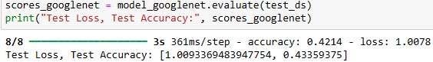

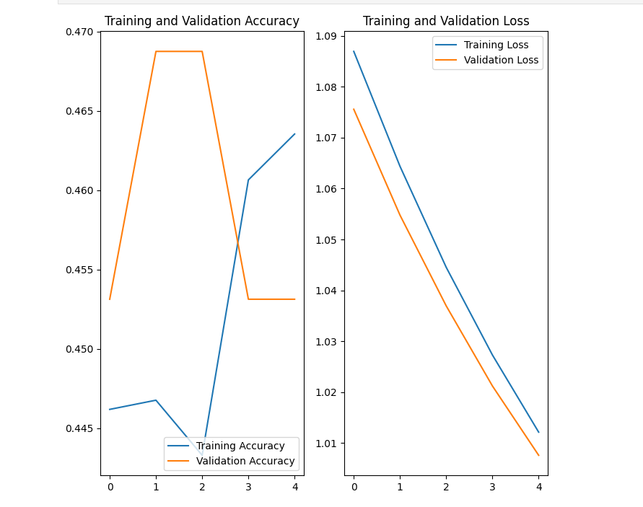

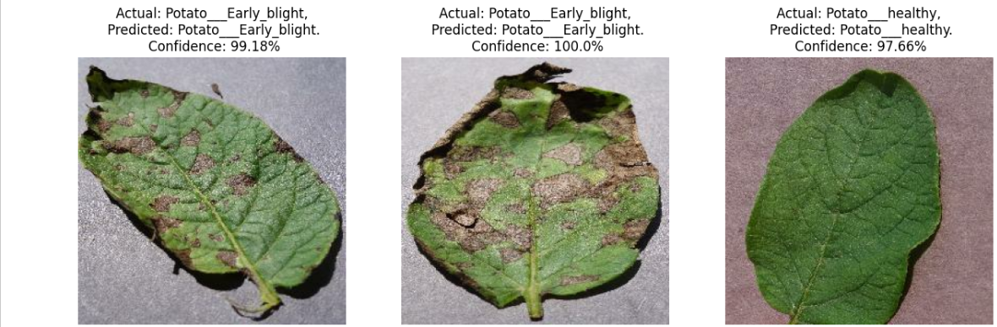

1. **ResNet**

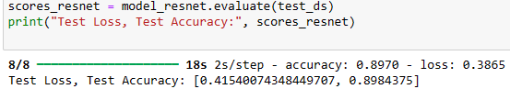

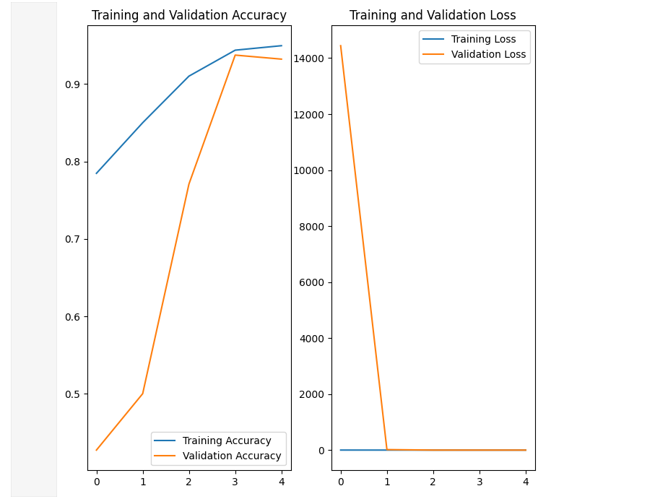

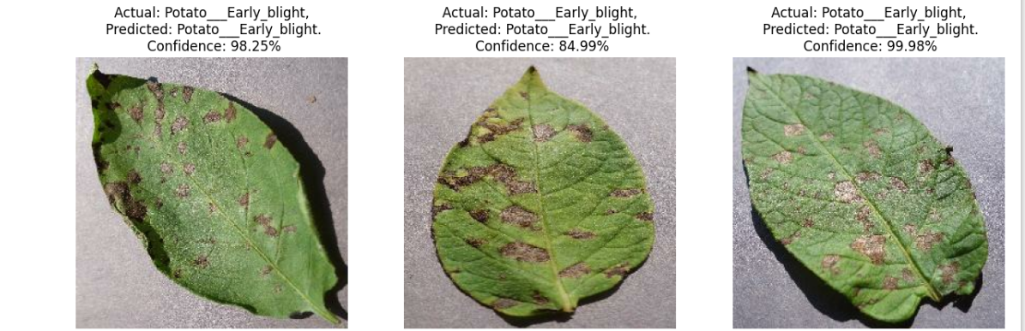

**Analysis**

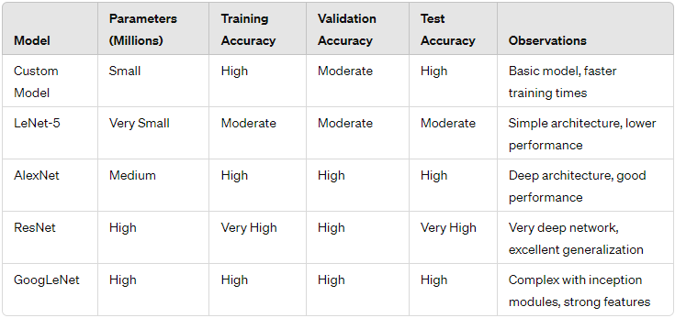

**References**

<https://www.tensorflow.org/api_docs/python/tf>

<https://keras.io/api/>

<https://keras.io/guides/>

<https://medium.com/codex/lenet-5-complete-architecture-84c6d08215f9>

<http://yann.lecun.com/exdb/publis/pdf/lecun-98.pdf>

<https://proceedings.neurips.cc/paper_files/paper/2012/file/c399862d3b9d6b76c8436e924a68c45b-Paper.pdf>

<https://paperswithcode.com/method/alexnet>

<https://www.cs.unc.edu/~wliu/papers/GoogLeNet.pdf>

<https://www.cv-foundation.org/openaccess/content_cvpr_2016/papers/He_Deep_Residual_Learning_CVPR_2016_paper.pdf>